Extreme Market or Market events Analysis Report

1. Introduction
2. Traditional Methods
   1. **Commodity Channel Index**

The Commodity Channel Index (CCI) is a versatile technical oscillator that is used to identify trends, cycles, and extreme conditions in the market. It was developed by Donald Lambert and introduced in Commodities magazine in 1980, originally aimed at identifying cyclical turns in commodities. However, the CCI has been widely adopted by traders in various markets, including equities and forex, due to its versatility

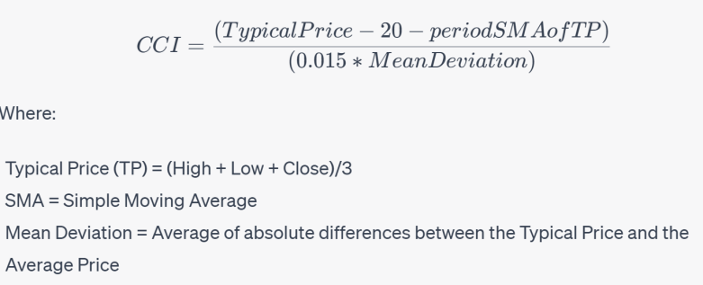

CCI measures how far away the current price is from a historical average price. The CCI is a type of oscillator, meaning it fluctuates above and below the zero line. If CCI is positive, it means the current price is above the average price, and if CCI is negative, the current price is below the average price.

CCI is typically used to identify overbought and oversold conditions in the market. According to traditional acknowledgement, CCI normally tends to oscillate between positive and negative 100. Readings above 100 imply an overbought condition, while readings below -100 imply an oversold condition. With this information, various trading strategies can be developed. For example, some traders use these levels to generate trading signals, buying when the CCI moves above -100 (coming out of an oversold condition) and selling when the CCI moves below +100 (coming out of an overbought condition).

Note that, unlike some other oscillator indices such as RSI and KDJ, which have an upper or lower bound, the CCI can continuously move higher or lower. Thus, the CCI index is not significantly influenced by passivation and marginal effect, which is beneficial for the detection of more extreme markets.

* 1. **Relative Strength Index**

The Relative Strength Index (RSI) is another momentum oscillator that measures the speed and change of price movements. It was developed by J. Welles Wilder and introduced in his 1978 book, "New Concepts in Technical Trading Systems." RSI calculates the ratio of higher closes to lower closes: stocks which have had more or stronger positive changes have a higher RSI than stocks which have had more or stronger negative changes.

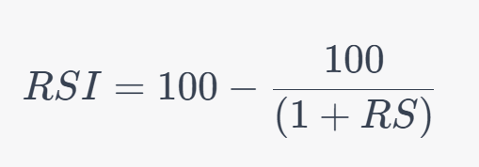

Where RS (Relative Strength) is the average gain of up periods divided by the average loss of down periods over a specified time frame. The most commonly used time frame for comparing up periods to down periods is 14, as in 14 trading days.

The RSI ranges from 0 to 100 and is typically used to identify overbought or oversold conditions in a market. An asset is usually considered overbought when the RSI is above 70 and oversold when it is below 30.

* 1. **Moving Average Convergence Divergence(MACD)**

The Moving Average Convergence Divergence (MACD) is a trend-following momentum indicator. It shows the relationship between two moving averages of a security's price. The MACD is calculated by subtracting the 26-period Exponential Moving Average (EMA) from the 12-period EMA. The result of that calculation is the MACD line. A nine-day EMA of the MACD, known as the "signal line," is then plotted on top of the MACD line, which can function as a trigger for buy and sell signals.

MACD can be used to detect abnormal signals using multiple methods, including the following:

1. MACD Line Crosses the Signal Line: When the MACD line (the difference between the 12-period EMA and the 26-period EMA) crosses above the signal line (the 9-period EMA of the MACD line), it can be a bullish signal suggesting that it might be a good time to buy. Conversely, when the MACD line crosses below the signal line, it can be a bearish signal suggesting it might be a good time to sell.
2. MACD Line Crosses the Zero Line: This is another signal that can indicate a change in the trend. When the MACD line crosses above the zero line, it indicates that the shorter-term moving average is above the longer-term moving average, which could be a bullish signal. Conversely, when the MACD line crosses below the zero line, it could be a bearish signal.
3. Divergence: If the price of a stock is making new highs while the MACD line is failing to reach new highs, this could be a bearish divergence indicating a potential price reversal. Conversely, if the price is making new lows while the MACD line is failing to reach new lows, this could be a bullish divergence.
   1. **Bollinger Bands**

Bollinger Bands is a technical analysis tool invented by John Bollinger in the 1980s. They are a type of statistical chart characterizing the prices and volatility over time of a financial instrument or commodity, using a formulaic method propounded by Bollinger himself.

Bollinger Bands consist of a middle band, which is a simple moving average (SMA), and an upper and lower band. The upper and lower bands are typically 2 standard deviations +/- from a 20-day simple moving average, but can be modified based on user preferences.

The bands are defined as follows:

1. Middle Band = 20-day simple moving average (SMA)
2. Upper Band = 20-day SMA + (2 x 20-day standard deviation of price)
3. Lower Band = 20-day SMA - (2 x 20-day standard deviation of price)

Bollinger Bands measure the highness or lowness of the price relative to previous trades and provide a relative definition of high and low. The prices are high at the upper band and low at the lower band.

Similar with MACD, there are multiple forms of signals for abnormal momentum or extreme market that can be detected using Bollinger Bands:

1. Price touching or exceeding the bands: When the price of a stock touches or exceeds one of the Bollinger Bands, it could indicate an extreme price movement. If the price touches or exceeds the upper band, it may suggest the stock is overbought. Conversely, if the price touches or exceeds the lower band, it may suggest the stock is oversold. However, this is not a standalone signal to buy or sell, as prices can remain overbought or oversold for extended periods during strong uptrends or downtrends.
2. Band width: The width of the Bollinger Bands can also provide information about market conditions. The bands widen during periods of high volatility and contract during periods of low volatility. If the bands are unusually narrow, it could suggest that the market is in a period of low volatility and that a significant price movement may be on the horizon. This is known as a "squeeze."
3. Band crossover: A band crossover occurs when the price crosses the middle band (the moving average). A crossover above the middle band may indicate upward momentum, while a crossover below may indicate downward momentum.
4. Repeated touches: If a stock's price repeatedly touches one band without touching the other, this could indicate a strong trend in the direction of the touched band. For example, if a stock's price repeatedly touches the upper band without touching the lower band, this could indicate a strong upward trend.
   1. On Balance Volume

On Balance Volume(OBV) is a momentum indicator that uses volume flow to predict changes in stock prices. The main idea is that volume precedes price movement, so if a stock is being accumulated or distributed, it may be a sign of an upcoming price move.

1. Trend Confirmation: If the price of a stock is rising and OBV is rising too, this is considered to be an upward trend confirmation. Similarly, if the price is falling and OBV is falling too, this is a downward trend confirmation. In both cases, the volume is confirming that traders are willing to keep buying or selling at new price levels.
2. Trend Divergence: If the price is rising but OBV is falling, this is a bearish divergence, suggesting that the upward trend may soon reverse. This is because even though the price is rising, the volume is not confirming it, indicating that traders may not be willing to buy at higher prices. Conversely, if the price is falling but OBV is rising, this is a bullish divergence, suggesting that the downward trend may soon reverse.
3. Volume Breakouts: A volume breakout occurs when OBV moves beyond its recent range and can be a sign of a strong trend. For example, if OBV moves above its recent high, it could be a sign that buyers are in control and a bullish trend may be in place.
   1. Stress Test
4. Developed Methods

The indices described above are mostly already been used or studied for decades. In this section, we can shift the focus to more newly developed methodologies. These methods are usually more complex and more concentrated on specific topics, and the performance can also be more inconsistent. Hence, it is suggested that these methods should be used combined with other indices.

1. Detection of Extreme Event with Tail Distribution Slope
2. Compare and Contrast
3. Conclusion

Title: Comparative Analysis of Stock Market Risk and Volatility Indices: Commodity Channel Index (CCI), Relative Strength Index (RSI), and Moving Average Convergence Divergence (MACD)

Abstract: This paper aims to provide an in-depth comparative analysis of three prominent stock market risk and volatility indices: the Commodity Channel Index (CCI), the Relative Strength Index (RSI), and the Moving Average Convergence Divergence (MACD). The study will delve into the mathematical inductions of the equations, their usage, effectiveness, pros and cons, and performance. The objective is to offer a comprehensive understanding of these indices and their applicability in the financial market.

I. Introduction The introduction will provide an overview of the importance of risk and volatility indices in the stock market. It will also introduce the three indices that will be the focus of the paper: CCI, RSI, and MACD.

II. Commodity Channel Index (CCI) This section will provide a detailed analysis of the CCI. It will begin with a mathematical induction of the CCI equation, followed by an explanation of its usage and effectiveness in the stock market. The pros and cons of the CCI will be discussed, along with its performance in different market conditions.

III. Relative Strength Index (RSI) This section will delve into the RSI. It will start with a mathematical induction of the RSI equation, followed by a discussion on its usage and effectiveness. The advantages and disadvantages of the RSI will be explored, along with its performance in various market scenarios.

IV. Moving Average Convergence Divergence (MACD) This section will focus on the MACD. It will begin with a mathematical induction of the MACD equation, followed by an examination of its usage and effectiveness. The pros and cons of the MACD will be discussed, along with its performance in different market conditions.

V. Comparative Analysis This section will compare and contrast the CCI, RSI, and MACD. It will examine their similarities and differences in terms of their mathematical equations, usage, effectiveness, pros and cons, and performance. The section will also discuss the conditions under which each index is most effective.

VI. Conclusion The conclusion will summarize the findings of the paper. It will also provide recommendations on the use of these indices based on the comparative analysis.

VII. References This section will list the sources of information used in the paper.

Note: This is a general outline for the research paper. The actual paper would need to be much more detailed, with each section containing a thorough analysis of the respective topic. The mathematical inductions would require a deep understanding of mathematical concepts and their application in financial analysis. The usage, effectiveness, pros and cons, and performance of each index would need to be discussed in detail, with supporting evidence from academic research and real-world examples. The comparative analysis would need to be comprehensive, examining each index from multiple perspectives and providing insightful conclusions.